Sprint Report  
Sprint 3 Submission

Submission Date: 02 March 2021

Team A

Gregorson Mahon T00057640

Taylor Peck T00483746

Nicholas Piluso T00586492

Contents

List of tasks for the previous week 3

List of tasks for the coming week 4

Application Server Backlog: 4

Web Site Backlog: 4

Project Management Tool Screenshot 5

Updated Mock-ups or Other Relevant Documents 6

# List of tasks for the previous week

|  |  |
| --- | --- |
| Task Name | Responsible Team Member |
| **Team Meeting for server connectivity:**   * Obtain/distribute server passwords * Set up PHPMyAdmin, PuTTY and WinSCP access | All Team Members |
| **Continue development on web site:**   * Upload exiting preliminary web site files to GitHub * Create functionality to create/signin a user * Integrate create/siginin functionality with the view/controller   Server side user validation | Taylor |
| **Finish initial development of SQL Database:**   * Upload database schema to server * Resolve any bugs/failures in the database schema that arise   **Switch to development of web site:**   * Onboard to the web development by reviewing exiting web site files * Begin working with Taylor to continue developing web interface components. | Gregorson |
| **Complete the Server Setup:**   * Resolve any connectivity bugs that come up during the server connectivity meeting.   **Continue development of the Application Server:**   * Develop ability to send emails, * Implement functions that create user messages, * Connect the app server code to the newly created database. | Nick |

# List of tasks for the coming week

|  |  |
| --- | --- |
| Task Name | Responsible Team Member |
| **Team Meeting for …** | All Team Members |
| **Continue development on web site:** | Taylor |
| **Continue development on web site:** | Gregorson |
| **Server Maintenance:**   * Resolve any server problems that require superuser intervention.   **Continue development of the Application Server:**   * Calculate which properties are inside which new outages and add a PropertyOutage record to the DB | Nick |

# Application Server Backlog:

1. Calculate which properties are inside which new outages and add a PropertyOutage record to the DB (use AppModelPolygonPointFunctions.py && use InsertPropertyOutages in AppModelDB.py) (***Assigned to Nick March 1st 2021***)
2. Deactivate PropertyOutage records in the DB where power has been restored to a property (use UpdatePropertyOutages in AppModelDB.py)
3. Reactivate a PropertyOutage in the DB where power has been lost again - if it was previously restored (use UpdatePropertyOutages in AppModelDB.py) (This is likely a low-priority
4. Retrieve user contact settings & property info from DB for updated/new outages so that informative messages can be created and sent to these users (add DB functionality to AppModelDB.py)
5. Send outage messages in the list ‘*ListOfOutageMessages*’ to the users (use functions in AppModelSESMail.py to send emails) (*this task is dependent on code written for item #4 above*)
6. Rename AppModelRetrieveJSON.py to AppController.py and move non-controller functions (json functions, etc) to their own Model files. *This is a cleanup task with low priority.*

# Web Site Backlog:

# Project Management Tool Screenshot

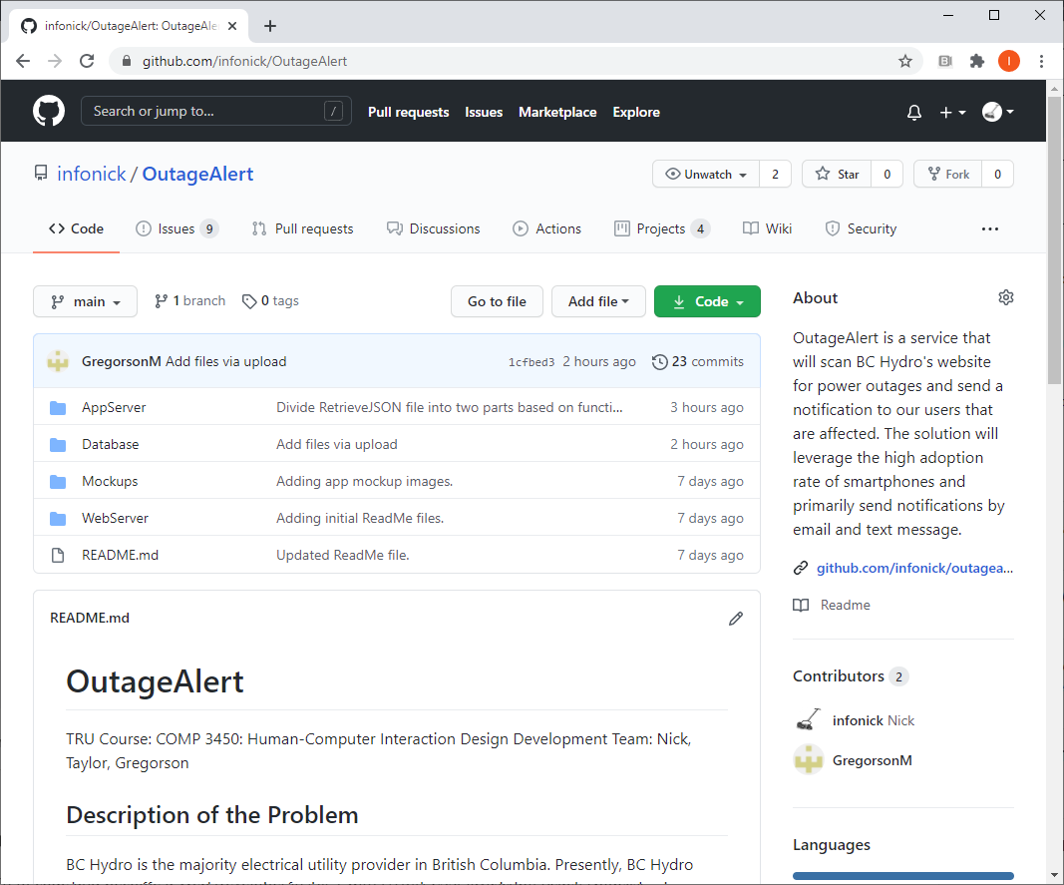

Interested readers may review the GitHub: <https://github.com/infonick/OutageAlert/>

# Updated Mock-ups or Other Relevant Documents

“You can include any other information such as screenshots of your app in progress or mock-ups showing what you plan to do in the coming week.”

N/A for this sprint